# AIM: Implement and analyze algorithms given below 1 Factorial (Iterative and Recursive).

**PROGRAM(Iterative):**

#include <iostream>

using namespace std;

int main()

{

int i,fact=1,number,counter=0;

cout<<"Enter any Number: ";

cin>>number;

for(i=1;i<=number;i++){

fact=fact*i;

counter++;

}

cout<<"Factorial of " <<number<<" is: "<<fact<<endl;

cout<<"Counter is:"<<counter;

return 0;

}

**OUTPUT:**

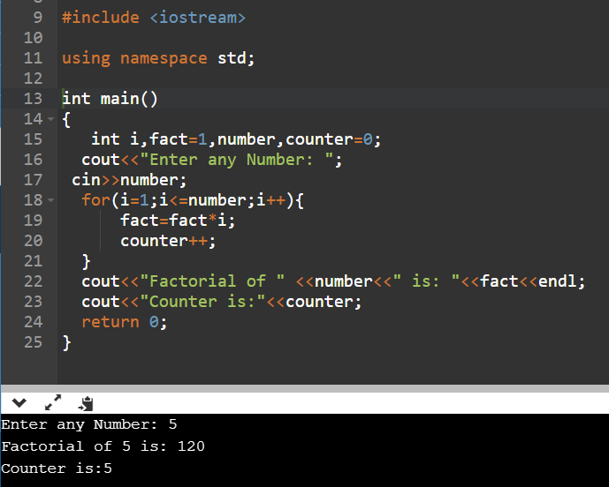

**ANALYSIS TABLE:**

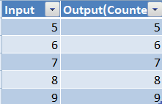

**GRAPH:**

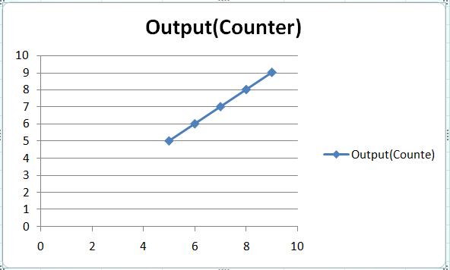

**CONCLUSION:** I Implemented and analyzed algorithms given below 1 Factorial using iterative method.

**PROGRAM(Recursive):**

#include<iostream>  
using namespace std;  
 int ctr=0;  
  
int factorial(int n)  
    {  
        if(n<0)  
        return(-1); /*Wrong value*/  
        if(n==0)  
        return(1);  /*Terminating condition*/  
        else  
        {  
            ctr++;  
            return(n*factorial(n-1));  
        }  
    }  
  
int main()  
{  
    int fact,number,counter;  
    cout<<"Enter the number to find it's factorial: ";  
    cin>>number;  
    fact=factorial(number);  
    cout<<"Factorial of the given number is: "<<fact<<endl;  
    cout<<"Counter is: "<<ctr<<endl;  
    return 0;  
}

**OUTPUT:**

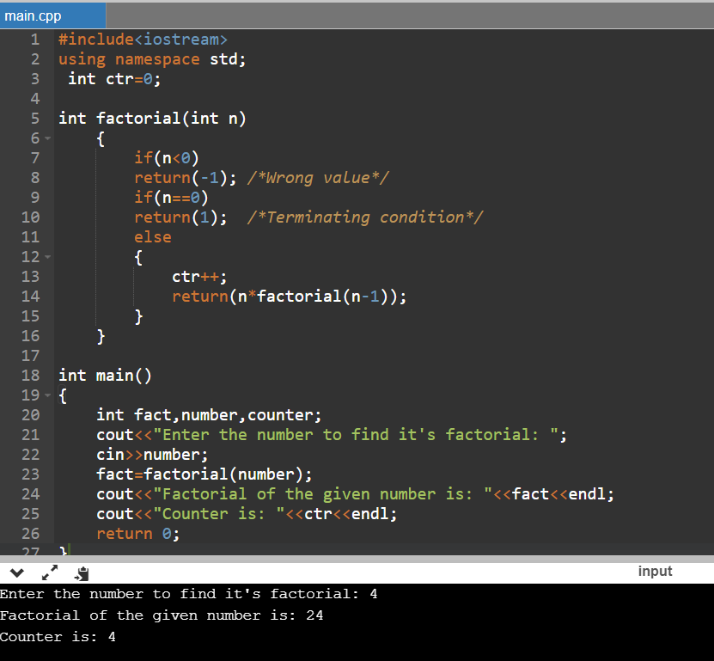

**ANALYSIS TABLE:**



**GRAPH:**



**CONCLUSION:** I Implemented and analyzed algorithms given below 1 Factorial using Recursive method.